Friday 27th March 2020

WORKSHEET 2

School: 41st Primary School of Patras
Name:
Surname:
Grade: 4th
Mark:

- Which hobby do/don't you like? Which hobby does/doesn't your friend like?

e.g I like swimming but I don’t like playing handball!

He likes fishing but he doesn’t like sailing!!!

I like ...........................................................but I don't like .......................................

He/She ......................................................but he/she ...............................................

2. Look at the pictures and write the names of the sports that follow:







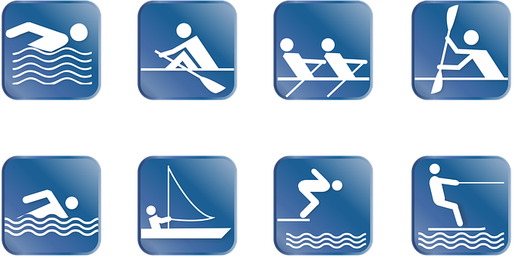

3. Tell the time.

a. Η ώρα είναι οκτώ και μισή.
……………………………………………………….

b. Η ώρα είναι εφτά και τέταρτο.

……………………………………………………….
c. Η ώρα είναι δώδεκα ακριβώς.
……………………………………………………….

d. Η ώρα είναι δύο παρά τέταρτο.

………………………………………………………..

4. Write the nationalities(εθνικότητες).

a. Amir is from Egypt. He is …………………………

b. Claudio is from Italy. He is ………………………..

c. Tina is from Albania. She is ………………………..

d. Yang is from China. He is ………………………….

e. Giorgos is from Greece. He is ………………………

5. Put the words in the right order.(Βάλε τις λέξεις στη σωστή σειρά).

a. sometimes/TV/watches/He

………………………………………………..
b. Helen/fast food/never/eats

………………………………………………..

c. George/exercises/often/in his garden

…………………………………………………

d. always/do/They/their homework

…………………………………………………

6. Find and correct the mistakes in these sentences.(Βρες και διόρθωσε τα λάθη σ΄αυτές τις προτάσεις.)

a. My mum always clean the house in the morning.

………………………………………………………….

b. I play often board games at the weekend.

…………………………………………………………...

c. We always are happy when we get presents.

……………………………………………………………

d. Mary go to school on weekdays.

...........................................................................................

