ΛΥΣΕΙΣ ΣΤΙΣ ΕΡΓΑΣΙΕΣ ΤΟΥ ΠΡΩΤΟΥ ΜΑΘΗΜΑΤΟΣ ΤΗΣ ΦΥΣΙΚΗΣ ΑΓΩΓΗΣ

ΔΗΜΗΤΡΙΑΚΑ

|  |  |  |  |  |  |  |  |  |  |  |  |  |  |  |  |  |  |  |
| --- | --- | --- | --- | --- | --- | --- | --- | --- | --- | --- | --- | --- | --- | --- | --- | --- | --- | --- |
| Α | Ξ | Κ | Χ | Υ | Λ | O | Π | Ι | Τ | Ε | Σ | Ν | Π | Ρ | Κ | Ε | Ο | Τ |
|  |  |  |  |  |  |  |  |  |  |  |  |  |  |  |  |  |  |  |
| Λ | Κ | Ε | Ο | Μ | Λ | I | Ο | Ρ | Α | Ρ | Ζ | Α | Ι | Τ | Ρ | Ο | Β | Α |
| Ε | Φ | Μ | Ι | Π | Ψ | Π | Υ | Α | Λ | Ρ | Γ | Φ | Τ | Υ | Θ | Φ | Α | Κ |
| Υ | Γ | Η | Κ | Ι | Τ | Φ | Ρ | Υ | Γ | Α | Ν | Ι | Ε | Σ | Ε | Κ | Ι | Ο |
| Ρ | Π | Θ | Ρ | Σ | Ω | Ν | Ε | Α | Ρ | Ζ | Μ | Ν | Σ | Ι | Ζ | Ρ | Μ | Υ |
| Ι | Τ | Ι | Ι | Κ | Μ | Ε | Σ | Ε | Α | Φ | Ρ | Ζ | Κ | Σ | Γ | Ι | Ν | Λ |
| Ε | Ω | Ξ | Θ | Ο | Τ | Ξ | Β | Θ | Κ | Τ | Υ | Λ | Τ | Α | Ρ | Τ | Λ | Ο |
| Π | Α | Τ | Α | Τ | Α | Κ | Ι | Α | Ζ | Δ | Ζ | Ε | Η | Ρ | Ρ | Σ | Α | Υ |
| Ε | Ν | Α | Ρ | Α | Ω | Ε | Ν | Β | Α | Ω | Ι | Η | Ψ | Ω | Μ | Ι | Β | Ρ |
| Κ | Ψ | Σ | Α | Υ | Ο | Α | Ε | Γ | Ξ | Χ | Σ | Κ | Θ | Σ | Υ | Ν | Ρ | Ι |
| Π | Υ | Ρ | Κ | Δ | Η | Μ | Η | Τ | Ρ | Ι | Α | Κ | Α | Μ | Ω | Ι | Γ | Χ |
| Τ | Ω | Δ | Ι | Θ | Σ | Π | Ο | Π | Κ | Ο | Ρ | Ν | Λ | Τ | Υ | Α | Υ | Β |

**Μεσοστοιχίδα**

* 1. ΠΑΤΑΤΕΣ
  2. ΚΟΥΛΟΥΡΙ
  3. ΤΟΣΤ
  4. ΜΑΚΑΡΟΝΙΑ
  5. ΠΡΩΙΝΟ
  6. ΑΛΕΥΡΙ

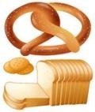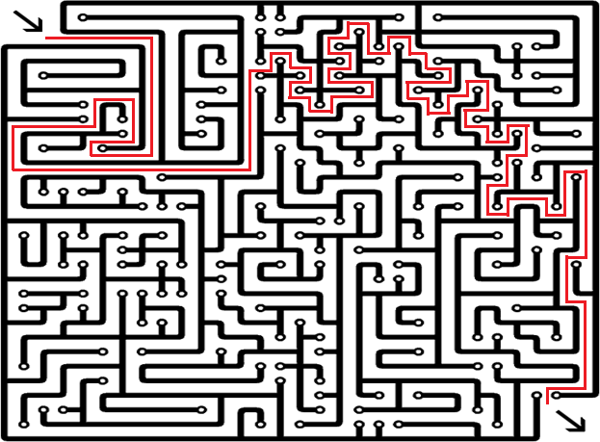

**ΦΡΟΥΤΑ -ΛΑΧΑΝΙΚΑ**

**ΛΥΣΕΙΣ**

### Αναγραμματισμοί

Μανταρίνι, Ενέργεια, Πορτοκάλι, Φλούδα

**Κρυπτόλεξο**

|  |  |  |  |  |  |  |  |  |  |  |  |  |  |  |  |  |  |  |  |  |  |  |
| --- | --- | --- | --- | --- | --- | --- | --- | --- | --- | --- | --- | --- | --- | --- | --- | --- | --- | --- | --- | --- | --- | --- |
| Δ | Φ | Γ | Η | Υ | Ξ | Θ | Ι | Φ | Ρ | Α | Ο | Υ | Λ | Α | Δ | Β | Δ | Ω | Ω | Γ | Ε | Τ |
| Γ | Η | Υ | Ξ | Μ | Θ | Υ | Φ | Τ | Η | Ξ | Θ | Μ | Ι | Φ | Η | Υ | Κ | Ε | Ρ | Α | Σ | Ρ |
| Ε | Ρ | Μ | Π | Ε | Ρ | Μ | Π | Α | Ν | Ε | Σ | Τ | Η | Ι | Μ | Ν | Ε | Ρ | Η | Θ | Κ | Γ |
| Φ | Ω | Π | Γ | Ρ | Σ | Η | Ε | Σ | Τ | Α | Φ | Υ | Λ | Ι | Ε | Γ | Ρ | Σ | Γ | Ρ | Σ | Ρ |
| Τ | Σ | Α | Τ | Α | Χ | Λ | Α | Δ | Ι | Η | Γ | Υ | Ξ | Ι | Η | Δ | Α | Τ | Ρ | Α | Ο | Ρ |
| Θ | Σ | Ν | Δ | Ρ | Α | Ο | Α | Ν | Α | Ν | Κ | Γ | Θ | Ι | Υ | Θ | Σ | Ο | Υ | Ν | Ι | Τ |
| Ι | Φ | Α | Α | Ν | Α | Ν | Α | Σ | Κ | Ε | Ρ | Π | Ε | Π | Ο | Ν | Ι | Ε | Τ | Α | Θ | Η |
| Λ | Ι | Ν | Ε | Ρ | Κ | Κ | Α | Ρ | Π | Ο | Υ | Ζ | Ι | Α | Σ | Τ | Ι | Τ | Υ | Ν | Ξ | Β |
| Φ | Ε | Α | Ρ | Τ | Η | Θ | Θ | Π | Ο | Ρ | Τ | Ο | Κ | Α | Λ | Ι | Θ | Τ | Ε | Ο | Ν | Α |

**Λαβύρινθος**

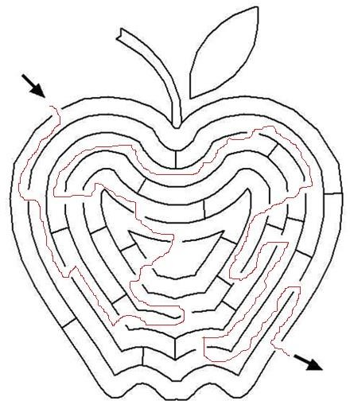

**Σταυρόλεξο**

|  |  |  |  |  |  |  |  |  |  |  |  |
| --- | --- | --- | --- | --- | --- | --- | --- | --- | --- | --- | --- |
| 1. | Μ | Α | Ρ | Ο | Υ | Λ | Ι |  |  |  |  |
| 2. |  |  | Α | Γ | Γ | Ο | Υ | Ρ | Ι |  |  |
| 3. |  | Μ | Ε | Λ | Ι | Τ | Ζ | Α | Ν | Α |  |
| 4. |  |  | Κ | Ρ | Ε | Μ | Μ | Υ | Δ | Ι |  |
| 5. |  | Α | Γ | Κ | Ι | Ν | Α | Ρ | Α |  |  |
| 6. |  |  |  |  | Ν | Τ | Ο | Μ | Α | Τ | Α |
| 7. |  |  |  | Κ | Α | Ρ | Ο | Τ | Ο |  |  |

**Εποχικότητα**



|  |  |  |  |  |
| --- | --- | --- | --- | --- |
| **Καλοκαίρι:** | **Φθινόπωρο:** | **Χειμώνας:** | **Άνοιξη:** | **Όλο τον χρόνο:** |
| καρπούζι | ρόδι | πορτοκάλι | πορτοκάλι | μπανάνα |
| πεπόνι | μήλο | αρακάς | αρακάς | πατάτα |
| σύκο | ακτινίδιο |  | φράουλες | μαρούλι |
| ροδάκινο |  |  |  | λάχανο |
|  |  |  |  | καρότο |

Λύσεις



Τ

Σ

Ο

Μεσοστοιχίδα

Α

Γ

Λ

Α

Σ

Κ

Ε

Λ

Ε

Τ

Ο

Β

Ο

Υ

Τ

Υ

Ρ

Ο

Φ

Ε

Τ

Α

Τ

Τ

Υ

Ι

Ο

Κρυπτόλεξο

Ο

Κ

Ι

Τ

Κ

Ε

Ρ

Τ

Ρ

Υ

Ο

Α

Ι

Γ

Ι

Ρ

|  |  |  |  |  |  |  |  |  |  |  |  |  |  |  |  |  |  |  |  |  |  |  |
| --- | --- | --- | --- | --- | --- | --- | --- | --- | --- | --- | --- | --- | --- | --- | --- | --- | --- | --- | --- | --- | --- | --- |
| Τ | Ψ | Α | Λ | Ο | Σ | Α | Κ | Ρ | Ι | Μ | Τ | Α | Ν | Θ | Ο | Τ | Υ | Ρ | Ο | Λ | Α | Μ |
| Α | Σ | Μ | Γ | Τ | Η | Ι | Φ | Ε | Τ | Κ | Λ | Ρ | Α | Ν | Γ | Α | Μ | Ε | Ρ | Τ | Ι | Α |
| Γ | Ω | Ε | Μ | Λ | Γ | Γ | Ε | Κ | Ε | Τ | Α | Ρ | Σ | Η | Κ | Η | Σ | Ι | Α | Τ | Σ | Ε |
| Ε | Ρ | Ν | Ν | Κ | Α | Ρ | Τ | Φ | Τ | Ρ | Τ | Ε | Κ | Λ | Α | Τ | Ε | Ρ | Ε | Α | Μ | Β |
| Α | Κ | Τ | Ν | Τ | Ε | Ρ | Α | Λ | Η | Η | Ω | Μ | Α | Η | Ι | Λ | Α | Ω | Γ | Ι | Ε | Ο |
| Ε | Τ | Α | Υ | Ε | Α | Λ | Η | Β | Α | Κ | Σ | Ι | Σ | Τ | Α | Κ | Ε | Μ | Α | Ι | Τ | Σ |
| Λ | Ε | Μ | Α | Ρ | Ο | Ρ | Ν | Α | Ι | Γ | Ω | Α | Ε | Φ | Ρ | Α | Ρ | Υ | Τ | Α | Σ | Τ |
| Α | Λ | Ε | Β | Τ | Ι | Κ | Η | Μ | Ο | Ε | Μ | Ν | Ρ | Α | Ο | Ρ | Α | Ζ | Η | Σ | Ο | Ω |
| Κ | Ρ | Ο | Υ | Ν | Α | Σ | Τ | Ο | Υ | Κ | Ρ | Τ | Ι | Ε | Κ | Τ | Σ | Η | Μ | Α | Β | Ρ |
| Λ | Α | Ρ | Ξ | Η | Γ | Κ | Ο | Υ | Ν | Τ | Α | Α | Μ | Ι | Φ | Σ | Α | Θ | Ρ | Ι | Ο | Σ |
| Ρ | Ι | Τ | Ρ | Α | Κ | Τ | Λ | Ν | Τ | Ν | Φ | Ν | Ι | Κ | Ο | Ι | Κ | Ρ | Α | Υ | Ν | Τ |
| Ε | Ρ | Κ | Ρ | Τ | Η | Σ | Ε | Τ | Α | Μ | Ο | Τ | Σ | Α | Ρ | Ε | Λ | Α | Σ | Ι | Ε | Α |
| Σ | Φ | Α | Ι | Β | Ω | Ι | Α | Σ | Β | Α | Ρ | Ν | Ξ | Ρ | Η | Σ | Α | Β | Α | Σ | Α | Κ |

Λαβύρινθος

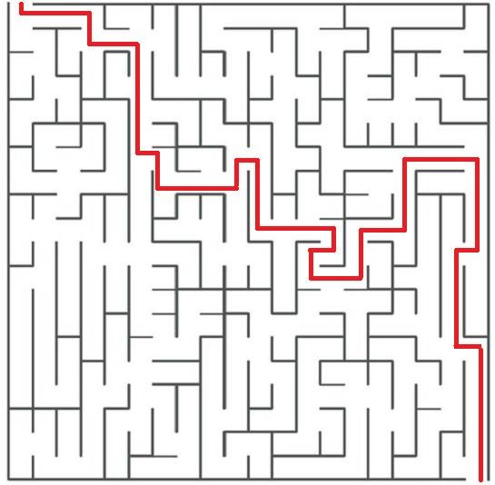

Χάρτης

Καλαθάκι Λήμνου

Λαδοτύρι

Μυτιλήνης

Φορμαέλα Αράχωβας

Κατίκι Δομοκού

Σαν Μιχάλη

Σύρου

Γραβιέρα Νάξου

ς